

**FACULTY OF ENGINEERING AND APPLIED SCIENCE**

|  |
| --- |
| **SOFE 3490U - Software Project Management**  **Lab 3 Report**  **Group**  **Friday, March 15, 2019** |

|  |  |  |  |
| --- | --- | --- | --- |
| **MEMBERS** | | | |
| **#** | **Last Name** | **First Name** | **Student ID** |
| **1** | Mobassher | Nafis | 100587562 |
| **2** | Chowdhury | Muhtasim | 100584755 |
| **3** | Shahriyar | Sakib | 100587434 |

**Product Development Plan**

**Effort Analysis**

We decide to use COCOMO to calculate the features of our development plan. Assuming our project has about 500,000 lines of code, we can now calculate the effort and development time for each of the three modes, organic, semi detached, and embedded using the COCOMO model and its equations.

E = ab(KLOC^bb)

D = cb(E)^db

KLOC = 500

Basic Model Values

|  |  |  |  |  |
| --- | --- | --- | --- | --- |
| **Software Projects** | **ab** | **bb** | **cb** | **db** |
| Organic | 2.4 | 1.05 | 2.5 | 0.38 |
| Semi Detached | 3.0 | 1.12 | 2.5 | 0.35 |
| Embedded | 3.6 | 1.20 | 2.5 | 0.32 |

1. **Organic Mode:** E = 2.4(500)^1.05 = 1637.31 person months

D = 2.5(1637.31) ^ 0.38 = 41.62 months

2. **Semi-detached mode:** E = 3.0(500)^1.12 = 3162.04 person months

D = 2.5(3162.04) ^ 0.35 = 41.96 months

3. **Embedded Mode:** E = 3.6(500)^1.20 = 6238.30 person months

D = 2.5(6238.30) ^ 0.32 = 40.96 months

Based on the above information, it is better to choose the embedded mode option as this project is very large and requires a large size of experienced team members that have to deal with a multitude of songs and albums from artists across the world.

**Activity Diagram**

The CPM/PERT activity diagram illustrates the schedule that would would be best to follow over the duration of this project. 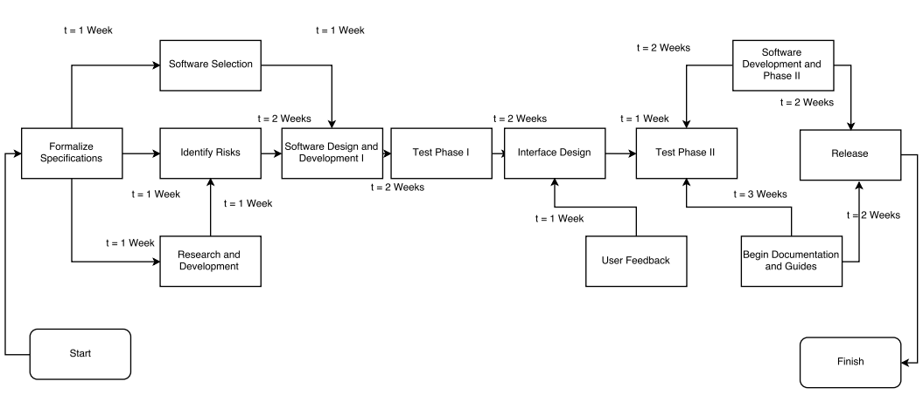

**Risk Analysis**

The first thing we need to do is identify the potential risks and create a checklist. The checklist will help us evaluate and identify which risks are higher than others and which risks we need to act upon immediately. We will prioritize the risks according to which risks are most likely to happen to the ones that are least likely to happen. If there are risks that are unavoidable, then the best thing to do is to mitigate it.

The main risk that this product development plan has is the lack of experience. This is our first project that we are working on and we are bound to make mistakes. We will lack in the time management department which can affect our product model. We will make naive decisions and we may not understand whether what we create is wanted by the target users. To minimize our risks, we have to first minimize the risks in ourselves by involving experienced personnel. An experienced project manager can polish our development plan and minimize risks. An experienced personnel can also help make important decisions and create an easy going environment. Another risk that may arise is the lack of motivation from a team of developers. If a member does not fulfill his role or achieve the goal set for him, then he/she will be replaced. Since we are building this project from scratch, there are some risks in building a secure network for users. We aim to minimize security flaws and patch up bugs that can be caused.

We need to identify all the risks at the beginning of the project, because if we are prepared for the risks that we may encounter then we can come up with strategies to avoid or mitigate the risks. We will brainstorm the possible risks we can face and note it down on a checklist so that we are prepared for it.